Principles of General Imaging in Geriatric Patients
Author: Kelli Welch Haynes, Ed.D, RT (R), FASRT, FAEIRS

Outline:
- Introduction
  - Definition: geriatrics and gerontology
  - Geriatrics as a special population of patients
- Elder Abuse in the Radiology Setting
  - Prevalence and types
  - Recognition in the imaging setting
- The aging process
  - Physical effects
  - Cognitive effects
  - Psychosocial effects
- The Physiology of Aging
  - Integumentary system
  - Organ systems
- Radiological Technologist Roles and Responsibilities in the Imaging of Geriatric Patients
  - Overall care and educating geriatric patients
  - Radiographic positioning for the geriatric patient
    - Chest
    - Abdomen
    - Upper extremity
    - Lower extremity
  - Technical factors to consider
- Conclusions

Learing Objectives
- Define geriatrics and gerontology
- Evaluate the radiologic technologists’ role when caring for a geriatric patient.
- Recognize radiologic and other signs of elder abuse that may present in the imaging envrionment
- Identify specific positioning recommendations for imaging geriatric patients

Highlights
- Providing care to geriatric patients in the imaging setting requires specific consideration for the physiology of aging, age-related risks, ageism, financial insecurity, and potential decreased mobility
- Radiology technologists must be aware of signs of elder abuse and able to report suscipion to the appropriate channels.
- Imaging procedures and positioning in geriatric patients may have to be adapted to account for reduced mobility, dexterity, and/or flexibility; balance and coordination issues; comorbidities that cause positional pain; and age-related physiological or pathophysiogical issues that may impact procedural details.

Introduction
Geriatrics is the branch of medicine dealing with the aged and the problems of aging individuals. The ongoing increase in the number of people older than 65 in the United States is well known. An even more dramatic aging trend exists among people older than 85 years of age. The number of people 100 years old is approximately 100,000 and increasing. This shift in the general population affects every aspect of the healthcare delivery system. The 2013 Pew Health Commission report noted that the “aging of the nation’s society and the accompanying shift to chronic care” foretell major shifts in care needed in which allied health professionals are significant providers of services. Gerontology is a specialized field for the aged, including illness prevention, management, health maintenance, and quality of life.1 As members of the allied health professions, radiographers are an essential component of the health care system. As the senior population increases, so does the number of medical imaging procedures performed on older adult patients. Radiologic technologists must be prepared to meet the challenges of this dramatic patient population shift. An understanding of geriatrics can foster a positive interaction between the radiographer and the older adult patient.

A Special Population
Acceleration of the “gray” American population began when “baby boomers” (population born between 1946-64) began to turn 50 in 1996.1 As of June 1, 2015, in the US, there were over 47 million people over the age of 65, and this number is expected to reach over 70 million by 2030.

The United States experience regarding the increase in the older adult population is not unique; it is global. As of 2015, 28 countries had more than 2 million people older than 65, and 12 additional countries had more than 5 million people older than 85. Research on family aspects of aging, economic resources, and the delivery of long-term care states that gender, race, ethnicity, and social class have consistently influenced the quality of the aging experience. The experience of aging results from the interaction of physical, mental, social, and cultural factors.

A problem facing aging Americans is healthcare finances. Older adults often base decisions regarding their healthcare not on their needs but exclusively on the cost of healthcare services, including imaging examinations. An increase in healthcare costs and the aging population go hand in hand. Most elderly have been diagnosed with at least one chronic condition. Heart disease, cancer, and stroke account for 7 of every 10 deaths among people older than 65. More people survive more serious illnesses such as cancer or heart attacks today. By 2025, an estimated 2/3 of the US healthcare budget will be devoted to services for older adults.

The United States is a multicultural society in which a generalized view of aging would be complex.1 Healthcare professionals need to know not only diseases and disorders common to a specific age group but also those familiar to a particular ethnic group. An appreciation of diverse backgrounds can help the radiologic technologist provide a personal approach when dealing with and meeting the needs of older adult patients. The economic status of older adults varies and significantly influences their health and well-being. Most older adults have an adequate income, but many minority patients do not. Single older adults are more likely to be below the poverty line. Economic hardships increase for single older adults, especially women. Of the population older than 85, 60% are women. Financial security is critical to an older adult. Many older adults are reluctant to spend money on what others may consider necessary for their well-being.

The attitudes of healthcare providers toward older adults impact their healthcare.3 Research indicates health care professionals have significantly more negative attitudes toward older patients than younger ones which translates to an inferior quality of care for older patients. This attitude must change if healthcare providers are to have positive interactions with older adult patients. These attitudes seem to be related to pervasive stereotyping of older adults, which justifies avoiding care and contact with them and the older adults being reminders of one’s own mortality. Ageism is a term used to describe the stereotyping of and discrimination against older adults. Ageism is similar to racism and sexism.1 Ageism emphasizes that older adults are perceived to be repulsive, and a distaste for the aging process exists. Quality of elderly care improves with an appreciation for this unique population, a positive attitude of providers, and information and education regarding the elderly and their unique conditions. Education would enable healthcare providers to adapt imaging and therapeutic procedures to accommodate mental, emotional, and physiological aging-related alterations and to be sensitive to cultural, economic, and social influences in caring for older adult patients. Ageism suggests most older adults are senile, miserable most of the time, and dependent rather than independent individuals.1 Healthcare providers must learn to appreciate the positive aspects of aging to assist older adult patients with positive experiences with imaging procedures.

Elder Abuse
Another emerging worldwide issue of older adults is elder abuse. It has been estimated that 2.1 million cases of elder abuse are reported each year. However, these numbers may be suspect because studies estimate that only one in five cases is reported to authorities. It is thought that elder abuse is approximately as common as child abuse. Elder abuse is the knowing, intentional, or negligent act by a caregiver or any other person that causes harm to a vulnerable adult. Table 1 demonstrates the forms of elder abuse.

Forms of Elder Abuse
Physical | inflicting physical pain or injury
Sexual | nonconsensual sexual contact of any kind
Neglect | failure by those responsible to provide food, shelter, health care, or protection
Exploitation | illegal taking, misuse, or concealment of funds, property, or assets of a senior
Emotional | inflicting mental pain, anguish, or distress through verbal or nonverbal acts
Abandonment | desertion of a vulnerable elder by anyone who has assumed the responsibility for the care or custody of that person
Self-neglect | failure of a person to perform essential self-care tasks, which threatens their own health or safety
Table 1: Forms of Elder Abuse

The typical victim of abuse is older than 75 years.6 Most studies of elder abuse show the incidence to be gender-neutral. Physical abuse is usually received from the victims’ spouse (50% of the time), and less often (25%) from the victim’s children, and in only 17% of cases is abuse from nonfamily caregivers. The radiologic technologist should be aware that the presence of injury is not proof of abuse. It is vital to be watchful for the warning signs of abuse or neglect. The warning signs of elder abuse and listed in Box 1.

Warning Signs of Elder Abuse
Bruises, pressure marks, broken bones, abrasions, and burns may indicate physical abuse, neglect, or mistreatment.
Unexplained withdrawal from normal activities, sudden change in alertness, and unusual depression may indicate emotional abuse.
Bruises around the breasts or genital area may occur from sexual abuse.
Sudden changes in financial situations may be the result of exploitation.
Bedsores, unattended medical needs, poor hygiene, and unusual weight loss may be indicators of possible neglect.
Behavior such as belittling, threats, and other uses of power and control by the caregiver may indicate verbal or emotional abuse.
Strained or tense relationships and/or frequent arguments between caregivers and the older adult.
Box 1: Warning Signs of Elder Abuse

The older adult is often embarrassed by the situation and may hesitate to communicate their concerns for fear of retaliation.6 The radiologic technologist needs to employ excellent communication skills, accurate documentation, and quality images, and the technologist should report any suspicions of neglect or abuse. Injuries sustained by older adults are typical to the head, face, and neck, as well as defensive injuries.

Effects of Aging
Aging is a broad concept that includes physical changes in people’s bodies, cognitive changes in their minds and mental capacities, social psychological changes in what we think and believe, and social changes in how we are viewed, what we expect, and what is expected of us.2 Aging and disease are not synonymous. The more closely a function is tied to physical capabilities, the more likely it is to decline with age, whereas the more closely a function depends on experience, the more likely it will increase with age. Older adults’ most common health complaints are weight gain, fatigue, loss of bone mass, joint stiffness, and loneliness. Weight gain, fatigue, loss of bone mass, and joint stiffness can be slowed through proper nutritional interventions and low-impact exercise. Exercise is critical to reducing the first four on the list.2

One of the best predictors of good health in later years is the number and extent of healthy lifestyles that were established earlier in life.4 Balance, coordination, strength, and reaction time all decrease with age. Falls associated with balance problems are common in the older adult population, resulting in a need to concentrate on walking.

Cognitive impairment can be caused by disease, aging, and disuse. Fears of cognitive loss, especially Alzheimer’s disease, are widespread among older persons. Dementia is a progressive impairment that eventually interferes with daily functioning. Alzheimer’s disease is the most common form of dementia. Dementia includes cognitive, psychological, and functional deficits, including memory impairment.7 With normal aging comes a slowing down and a gradual wearing out of bodily systems, but normal aging does not include dementia. Yet the prevalence of dementia increases with age. Persistent disturbances in cognitive functioning, including memory and intellectual ability, accompany dementia. Healthcare professionals are more likely to encounter people with this type of impairment. It is important not to overwhelm older adults with instructions. When giving instructions, speak slowly. Most older adults work at maintaining and keeping their mental functions by staying active through mental games and keeping engaged in regular conversation.

Each older adult is a unique individual with distinct characteristics.1 Research has shown that health status is an excellent predictor of happiness. Greater social contact, health satisfaction, low vulnerable personality traits, and fewer stressful life events have been linked to successful aging. Self-efficacy is the level of control over one’s future; many older adults feel they do not have control over their future. Environmental factors can lead to depression and decreased self-efficacy. Also, an increase in illness will usually parallel a decrease in self-efficacy.

Factors that increase the risk of depression and decrease self-efficacy include illness, medical emergencies, living on a fixed income, few choices in personal living arrangements, and changing roles from independence to dependence.1 The family dynamic of a parent caring for children and grandchildren may evolve into the children caring for the aging parent. Older adulthood is also a time of loss.4 The older person may have experienced many losses. Losses may include the death of a spouse and friends and loss of income owing to retirement. Loss of health may be the reason for the healthcare visit. Radiologic technologists need to be sensitive to the fact that an older adult may have to deal with many social and physical losses quickly. Radiologic technologists must recognize symptoms resulting from these losses to communicate and interact effectively with this population.3

Sight, hearing, taste, and smell are sensory functions that decrease with age.5 It is helpful to provide one instruction at a time, reduce background noise and dim the lights because older adults struggle with bright lights and tuning out background noise. Also, speak slowly, distinctly, and directly to the patient. Many older individuals become adept at lip reading to compensate for hearing loss. Do not assume all elderly are hard of hearing. Adjust voice volume as needed after assessment of the patient’s hearing.

Physiology of Aging of the Organ Systems
Health and well-being depend on how well organ systems can work together to maintain internal stability.1 With age, there is a gradual impairment of these homeostatic mechanisms.2 Older adults experience non-uniform, gradual, ongoing organ function failure in all systems.5 Many organs gradually lose strength with advancing age. These changes place older adults at risk for disease or dysfunction, especially in the presence of stress.2 Eventually, the likelihood of illness, disease, and death increases. Although aging is inevitable, the aging experience is highly individualized and is affected by heredity, lifestyle choices, physical health, and attitude. A significant portion of usual aging risks can be modified with positive shifts in lifestyle.

Biological age is more critical than chronological age when determining the health status of older adults.2 Chronological age is the number of years a person has been alive, while biological age refers to how old a person seems. The functional capacity of significant body organs varies with advancing age. Environmental and lifestyle factors affect age-related functional changes in the organs. Advancements in medical technology have extended life expectancy by nearly 20 years over the past half-century. People are healthier longer; this results from health promotion and secondary disease prevention, and lifestyle factors such as diet, exercise, and smoking cessation have effectively reduced the risk of disease. Most elderly have been diagnosed with at least one chronic condition. Today, more people survive more severe illnesses, such as cancer or heart attack, than 50 years ago. Table 2 demonstrates the top 10 chronic conditions affecting individuals aged 65 and over.

Top 10 Chronic Conditions of Individuals Aged 65 and Older
Arthritis | Deformity or orthopedic impairment
Hypertension | Chronic sinusitis
Hearing impairment | Diabetes
Heart disease | Visual impairment
Cataracts | Varicose veins
Table 2. Top 10 Chronic Conditions of Individuals Aged 65 and Older
Integumentary System
The first apparent signs of aging are visible in the integumentary system.5 The most common skin diseases are herpes zoster (shingles), malignant tumors, and decubitus ulcers. Skin membranes flatten and become more vulnerable to abrasions and blisters. Wrinkling and thinning are due to decreased collagen and elastin in the dermis. Thinning of skin in the face, back of hands, and soles of feet also occurs. Loss of this “fat pad” on the feet can cause foot conditions. The most significant and apparent changes are graying, thinning, and hair loss. The gradual loss of functioning sweat glands increases the threshold for pain stimuli, making older people vulnerable to heat strokes. A significant problem is chronic exposure to sunlight which increases the risk of skin cancer. The most common skin tumors are basal cell carcinoma, malignant melanoma, and squamous cell carcinoma.

Nervous System
The nervous system is the primary regulatory system of all other systems of the body.5 Central nervous system disorders are one of the most common causes of disability. Loss of myelin in axons contributes to the decrease in nerve impulse velocity. The elderly are vulnerable to the effects of atherosclerosis. When blood flow to the brain is blocked, brain tissue is damaged. Repeated episodes can lead to multi-infarct dementia. Changes in blood flow and oxygenation to the brain slow down the time to carry motor and sensory tasks requiring speed, coordination, balance, and fine motor skills. This decrease puts older people at higher risk for falls. High blood pressure is a risk and can be decreased with medication, weight loss, diet, and exercise.

Sensory System
All of the sensory systems change with age.5 Beginning around age 40, focusing on near objects becomes increasingly difficult. The lens of the eye becomes less pliable, starts to yellow, and becomes cloudy resulting in farsightedness, known as presbyopia. Distorted color perception and cataracts also begin. Changes in the retina affect the ability to adapt to changes in lighting. Hearing impairment is common; men are affected more often than women. Speech discrimination is problematic in noisy surroundings. There is a decline in sensitivity to taste and smell. This decline in taste is due to a decreased number of taste buds, decreased saliva, and dry mouth. Hyposmia, impairment of the ability to smell, accounts for decreased appetite and irregular eating habits.

Musculoskeletal System
Musculoskeletal dysfunction is a major cause of disability in the elderly.5 Osteoporosis is one of the most significant changes. Risk factors include estrogen depletion, calcium deficiency, physical inactivity, testosterone depletion, alcoholism, and smoking. The rate of new bone resorption surpasses the rate of new bone formation at age 40. This accounts for 40% of bone mass loss in women and 30% in men. Degenerative joint disease of weight-bearing joints and the hands are the most commonly affected of the musculoskeletal system. At age 40, most adults have osteoarthritic changes visible on x-rays of the c-spine.

Cardiovascular (CV) System
The cardiovascular system circulates blood which delivers oxygen and nutrients to all body parts and removes waste products.5 Damage to this system can have negative implications for the entire body. CV disease is the most common cause of death worldwide. Maximum heart rate during exercise decreases with age; older people become short of breath and tire quickly. Loss of arterial elasticity results in increased systolic blood pressure, increasing the risk for heart disease and stroke. Decreased blood flow to the digestive tract, liver, and kidneys affects the absorption, distribution, and elimination of substances such as medications and alcohol. Atherosclerosis, fatty plaques in arterial walls which make the artery prone to the formation of clots, is common. Plaques can cause the arterial wall to balloon, increasing the risk of aneurysm. Complications can lead to embolism, heart attack, or stroke. Congestive heart failure is the inability of the heart to propel blood at a sufficient rate, and volume is also common. Preventive health measures include a healthy diet, exercise, control of high blood pressure, and smoking cessation.

Gastrointestinal (GI) System
Gastrointestinal system disorders include malignancies; colorectal cancer is second to lung cancer as a cause of cancer-related mortality.5 Early detection measures are very effective and increase survival. Conditions also include peptic ulcer disease, GI bleeding, pancreatitis, difficulty swallowing, diverticulitis, gastric outlet obstruction, esophageal foreign bodies, constipation, and fecal incontinence. Mouth and teeth pain, side effects of medications, decreased saliva, and dry mouth can lead to nutritional deficiencies, malnutrition, and dehydration. Most disorders are related to a decrease in the rate of gastric acid production and secretions, as well as decreased motility. Diverticulosis, a common problem, develops when the large intestine herniates through the muscle wall. Healthy habits, as previously mentioned, are beneficial. The secret to survival for colon and rectal cancer is early detection. Stool samples and rectal exams are very effective.

Immune System
Age takes its toll on the immune system.5 Immunity implies protection from infection. Age-related decline of immune system functioning makes the elderly more vulnerable to diabetes, pneumonia, and nosocomial infections. Influenza, pneumonia, tuberculosis, meningitis, and urinary tract infections are prevalent among the elderly. Three general categories of illness that preferentially afflict the elderly are infections, cancer, and autoimmune disease.

Respiratory System
As we age, the lungs lose some of their elastic recoil, trapping air in the alveoli.5 This decreases the rate of oxygen entering the bloodstream and the elimination of carbon dioxide. Breathing muscles become slightly more rigid, which can account for shortness of breath on physical stress. The rib cage can also stiffen, causing kyphosis.

Hematological System
In the hematological system, anemia is a primary concern.5 Anemia causes pale skin, shortness of breath, and fatigue. As bone ages, the marrow has more difficulty maintaining blood cell production as the body is stressed. Anemia is not a single disease but a syndrome with several different causes. Some causes include insufficient dietary intake, inflammation, or destruction of the GI lining, which affects the ability to absorb vitamin B12.

Genitourinary (GU) System
Most GU changes are associated with incontinence due to bladder capacity and muscle structure changes.5 This incontinence leads to social and hygiene concerns. The number of nephrons in kidneys decreases dramatically. A regularly prescribed dose of medications could be an overdose in the elderly due to a reduced reserve capacity of the kidneys. The role of the kidneys is to maintain the body’s water balance and regulate the concentration according to the body’s needs which diminishes with age. Acute and chronic renal failure can affect many elderly adults in their later years. Benign prostatic hyperplasia is common in men over age 70. Enlargement of the prostate gland obstructs urine flow. Prostate cancer is the 3rd most common cancer in males; more than 85% of tumors are found after age 65.

Endocrine System
The endocrine system is another principal regulatory system of the body.5 Age-related changes in thyroid function result from inadequate responses of target cells to thyroid hormone. Diabetes mellitus-is the most common disease. Non-insulin-dependent diabetes mellitus increases in frequency with age and accounts for 90% of all cases. Regular exercise and weight loss can reduce the risk of non-insulin-dependent diabetes.

Radiological Technologist’s Role in Caring for and Imaging Elderly Patients
Patients typically arrive at the imaging department with a natural anxiety because they have little knowledge of the procedure or the highly technical equipment used for their procedures.3 Fear concerning the exam results exacerbates increased anxiety levels. Educating the patient about the examination makes for a less stressful experience and improves patient compliance and satisfaction. Good communication and listening skills connect the technologist and the patient. Communicate with warmth, empathy, and a positive attitude. If it is evident the patient cannot hear or understand verbal directions, it is appropriate to speak lower and closer.5 Background noise can be disruptive and should be eliminated when giving precise instructions. Treat the patient with dignity and respect. Give instructions individually to allow the person time to process your request. Extra time with older adults may be necessary to accommodate their decreased ability to process information rapidly. Allow the patient time to rest between projections and procedures. Avoid adhesive tape; elderly skin is thin and fragile. Provide warm blankets in cold exam rooms. Use table pads and handrails.3

Always access the patient’s medical history before contrast media is administered.3 Because of age-related changes in kidney and liver function, only the amount, not the type, of contrast media is varied for older adults. Compromised kidney function, due to a decrease in nephrons, causes older adults to be more prone to electrolyte and fluid imbalance, which can be life-threatening. They are also more susceptible to the effects of dehydration because of diabetes and/or decreased renal or adrenal function. Patient assessment should include a history of liver, kidney, or thyroid disease and a history of reactions to medications or contrast agents. Patient assessment should include sensitivity to aspirin, over-the-counter and prescription drug history, and history of diabetes and hypertension.

The radiologic technologist must be selective in locating an appropriate vein. The technologist should consider the vein's location and condition, decreased skin integrity, and duration of the therapy. Thin, superficial veins, repeatedly used veins, and veins in areas where the skin is bruised or scarred should be avoided.

The patient should be assessed for swallowing impairments, which could lead to difficulty drinking liquid contrast agents. The patient should be instructed to drink slowly to avoid choking, and an upright position helps prevent aspiration.

Balance and coordination can be affected by normal aging.5 Their fear of falling can be diminished by assistance in and out of the wheelchair and to and from the table. Preventing opportunities for falls is a necessity for the radiographer. Elderly patients often experience vertigo and dizziness when moving from recumbent to sitting. Give the patient time to rest between positions to mitigate these sensations. Using table handgrips and assistance from the radiographer creates a sense of security, resulting in a compliant and trusting patient.

Use caution in turning and holding older adults due to age-related changes in the skin.5 Excessive pressure on the skin will cause it to break and tear. Adhesive tape should be avoided since it can irritate and easily tear the skin. The loss of fat pads makes it difficult for older adults to lie on the table for long periods. A table pad can help reduce friction between the table and the patient's skin. Sponges, blankets, and positioning aids will make the procedure more bearable. The radiologic technologist may need to provide blankets due to thinning skin, which hinders the ability to keep warm. Box 2 summarizes suggestions for working with older adult patients.8

When working with older adulty patients, the radiologic technologistc should:
Take time to educate the patient and family and/or caregiver
Speak lower and closer
Treat the patient with respect and dignity
Give the patient time to rest between projections
Avoid adhesive tape; it can tear older adult skin
Provide warm blankets in cold examination rooms
Use table pads and handrails
Always access the patients’ medical history before contrast medium is administered
Box 2. Working with Older Adult Patients in the Imaging Setting

The whole person must be treated, not just symptoms of illness or injury.3 Adapting procedures to accommodate the needs of geriatric patients is a critical responsibility based almost exclusively on the radiographer’s knowledge, abilities, and skills.3,8 An understanding of the physiology and pathology of aging, an awareness of the social, psychosocial, cognitive, and economics of aging are required to meet the needs of the elderly population.4 Radiographers must be able to differentiate between age-related changes and disease processes.

The production of quality images requires professional decision-making to compensate for physiological changes.3 Taking time to educate patients about procedures makes for a less stressful experience and improves patient compliance and satisfaction.8 More time with older adult patients may be necessary to accommodate their decreased ability to process information rapidly.

Radiographic Positioning for Geriatric Patients
The preceding discussions and understanding of the physical, cognitive, and psychosocial effects of aging can help radiographers adapt to the positioning challenges of the geriatric patient.3 In some cases, routine exams need to be modified to accommodate the patient's limitations, safety, and comfort. Communicating clear instructions with the patient is essential.8

Chest
The position of choice for chest imaging is upright; however, an older adult may be unable to stand without assistance for this exam.8 Have the patient wrap their arms around the chest stand as a means of support and security (Figure 1a).8 The patient may be unable to hold his arms over his head for the lateral projection. The radiographer should provide extra security and stability while the patient moves their arms up and forward. If the patient can not stand, the exam may be done in a wheelchair (Figure 1b).3,8 Hyperkyphosis (humpback) can result in the lung apices being obscured, and the abdomen may cover the lung bases. In the sitting position, respiration may be compromised, so be sure and express the importance of taking a deep breath.8 Position the image receptor higher than usual for patients with kyphosis because the shoulders and apices are higher. Radiographic landmarks may change with age, and the centering may need to be lower if the patient is extremely kyphotic. When positioning the patient for a sitting lateral, the radiographer should place a large sponge behind the patient to lean him forward.

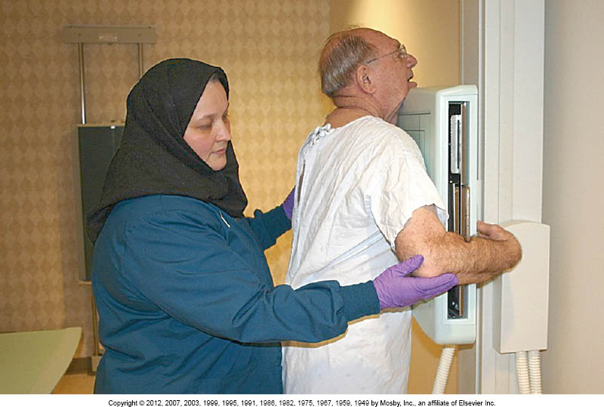
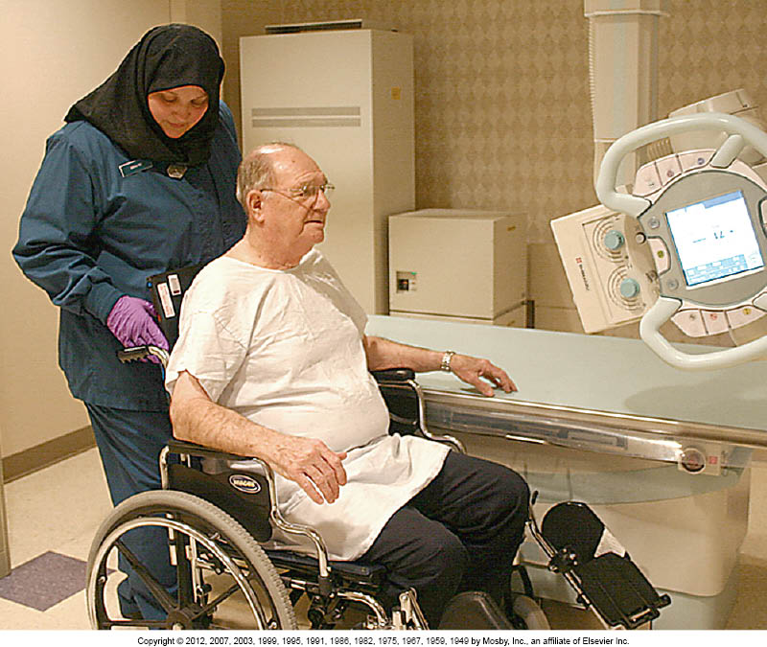

Figure 1. Alternative Standing (a) and Wheelchair (b) Positioning for Chest Imaging in an Elderly Patient

Spine
Radiography of the spine may be painful for a patient with osteoporosis who is lying on the exam table.8 Use positioning aids such as sponges, sandbags, blocks, or a pad, as long as they will not compromise the quality of the images (Figure 2). Performing the images with the patient in the upright position is also possible if the patient can safely tolerate this position. The combination of cervical lordosis and thoracic kyphosis can make positioning and visualization of the cervical and thoracic spine difficult. The thoracic and lumbar spines are common sites for compression fractures.

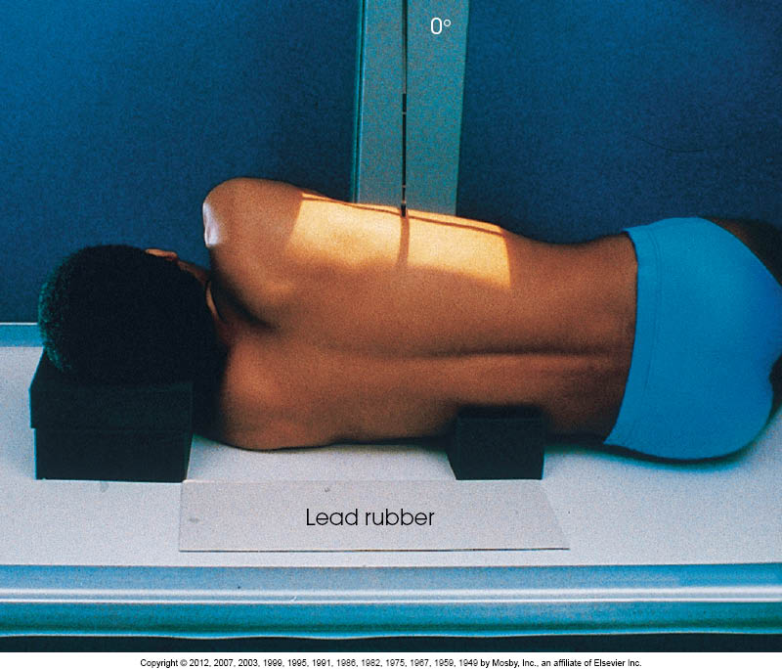

Figure 2. Alternative Positioning for Spinal Imaging in an Elderly Patient

Pelvis and Hips
Osteoarthritis, osteoporosis, and injuries resulting from falls contribute to hip pathologies.5 A common fracture in older adults is the femoral neck. An anterioposterior (AP) projection of the pelvis should be done to examine the hip.8 The radiographer should not attempt to rotate the limbs if the indication is trauma. The second view taken should be a cross-table lateral of the affected hip. If hip pain is the indication, assist the patient in internal rotation of the legs using sandbags If necessary.

Upper Extremity
Positioning the geriatric patient for upper- extremities projections can present its challenges.8 Often, upper extremities have limited flexibility and mobility. A cerebrovascular accident, or stroke, may cause contractures of the affected limb. Contracted limbs cannot be forced into position, and cross-table views may need to be done. The inability of the patient to move his limb should not be interpreted as a lack of cooperation. The routine AP and lateral projections can be supported using sponges, sandbags, and blocks to raise and support the extremity being imaged (Figure 3a). Supination is often a problem in patients with contractures, fractures, and paralysis (Figure 3b). The shoulder is also a site of decreased mobility, dislocation, and fractures. The technologist should assess how much movement the patient can do before attempting to move the arm.
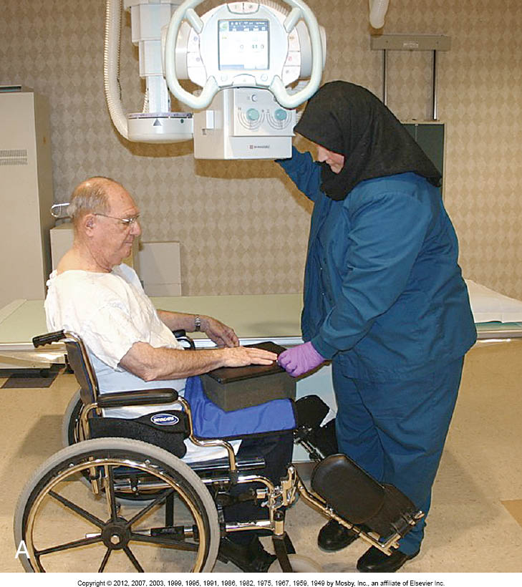
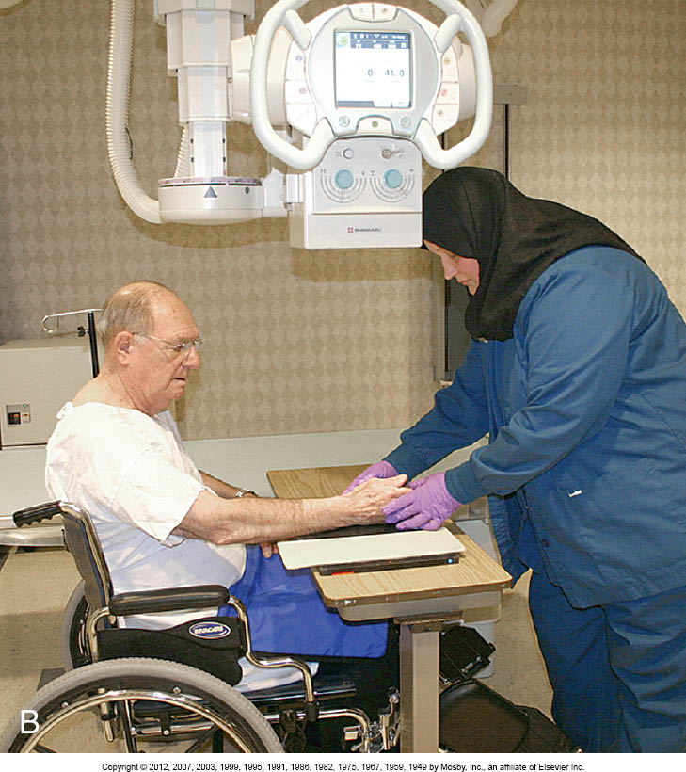

Figure 3. Alternative Positioning for Upper Limb Imaging Utilizing Limb Support (a) and to Address Supination (b) in an Elderly Patient

Lower Extremity
The lower extremity may also have limited flexibility and mobility.5 The ability to dorsiflex the ankle may be reduced due to neurological disorders.7 Imaging on the x-ray table may need to be modified when a patient cannot ambulate from the wheelchair to the x-ray table, therefore, the image may need to be performed with the patient in the wheelchair (Figure 4A) .8 Flexion of the knee may be impaired and require a cross-table lateral projection (Figure 4B). If a tangential projection of the patella is necessary, and the patient can turn on his side, the radiographer can place the image receptor superior to the knee and direct the central ray perpendicular through the patellofemoral joint. Positioning sponges and sandbags can be used to support and maintain the position of the body part being imaged.

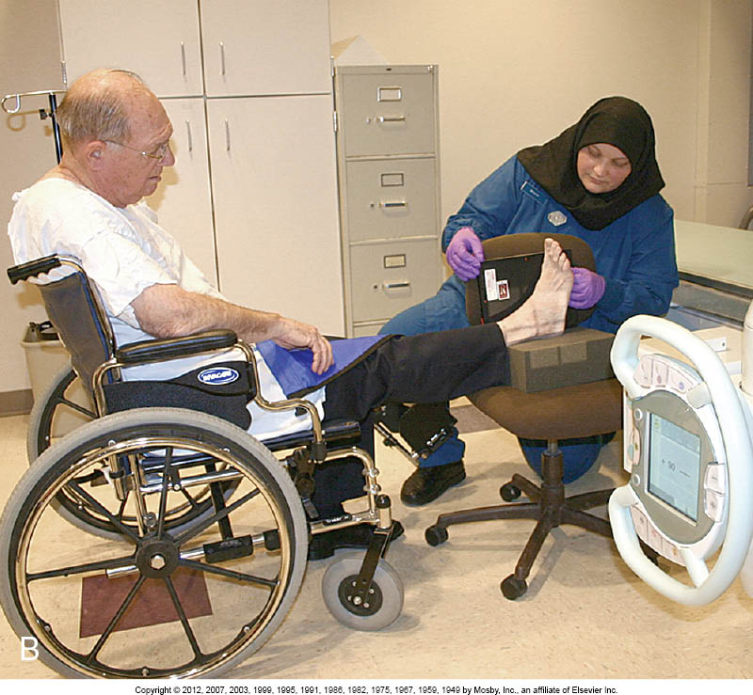
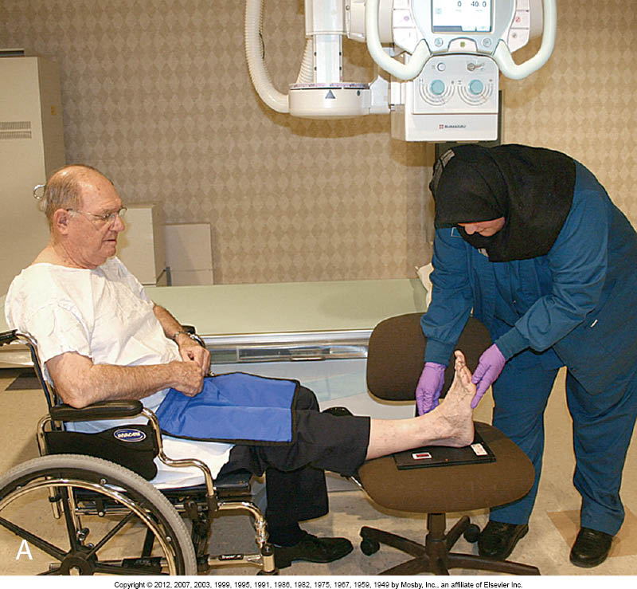

Figure 4. Alternative Wheelchair Positioning for Lower Limb Imaging (a), including Cross Table Lateral Projection

Technical Factors
Exposure factors also need to be considered when imaging the geriatric patient.3,8 Technical factors have to be adjusted to accommodate disease and normal age-related changes. To make correct technique adjustments for pathology and age-related changes, radiographers must know whether the disease/change is additive or destructive.8 The loss of bone mass and atrophy of tissues often require a lower kilovolt peak (kVp) to maintain sufficient subject contrast. kVp is also a factor in chest images when there may be a large heart and pleural fluid to penetrate. Patients with emphysema require reduced technical factors to prevent overexposure of the lung field. Time may also be a significant factor. Geriatric patients may have problems maintaining the positions necessary for the exams. Therefore, shorter exposure times help reduce voluntary and involuntary motion and breathing. The radiographer must ensure that the geriatric patient clearly hears and understands the breathing instructions.

Conclusion
Technologists will continue to see a change in healthcare delivery with an increasing population of people over 65. There will continue to be an increase in the number of medical imaging procedures performed on older adults. Demographic and social effects of aging determine how older adults adapt and view the process of aging. Family size, perceptions, economic resources, gender, race, ethnicity, social class, and availability of health care all impact the quality of the aging experience. Healthier lifestyles will create a generation of successfully aging adults. Whether positive or negative, healthcare professionals' attitudes will impact the care provided to the elderly. The aging experience is affected by heredity, lifestyle, physical health, and attitude. Radiologic technologists must use knowledge, abilities, and skills to adjust imaging procedures to accommodate elderly patients. The safety and comfort of the patient are essential. Implementing communication, listening, sensitivity, and empathy skills all lead to patient compliance. Successful imaging of elderly patients depends on the radiographer’s competence and knowledge of this unique population.

References

Majercsik, E. Hierarchy of Needs of Geriatric Patients. Gerontology. 2005: 51(3): 170-173.
Garza, A. The aging population: The increasing effects on health care. Pharmacy Times. 2016; 82(1).
Rarey LK. Radiologic technologists’ responses to elderly patients. Rad Technol. 2008;69(6):566-572.
Lambing AY, Adams DC, Fox DH, Divine G. Nurse practitioners’ and physicians’ care activities and clinical outcomes with an inpatient geriatric population. J Am Acad Nurs Pract. 2014;16(8):343-352.
Potter PA, Perry AG, Stockert PA, Hall A. The aging body systems: Explaining physiological aging. Fundamentals of Nursing. 10th ed. 2017. Elsevier, St. Louis, MO.
Clark, JG, English, K. Elder Abuse: A need for heightened vigilance. Audiology Today. 2022; 34(6).
Lang MM. Screening for cognitive impairment in older adults: Recommendation statement. Nurse Pract. 2020;26(11): 26, 32-37, 41.
Rollins JH, Long BW, Curtis T., eds. Merrill’s Atlas of Radiographic Positioning and Procedures. 15th ed. Volume 2. St. Louis, MO: Mosby; 2022.

